1. Write a C program to intialise the array Dynamically and print the array?

Code:

#include<stdio.h>

int main(){

int n;

printf("enter the size of array:");

scanf("%d",&n);

printf("Enter the elements:");

int a[n];

for(int i=0;i<n;i++){

scanf("%d",&a[i]);

}

for(int i=0;i<n;i++){

printf("%d ",a[i]);

}

return 0;

}

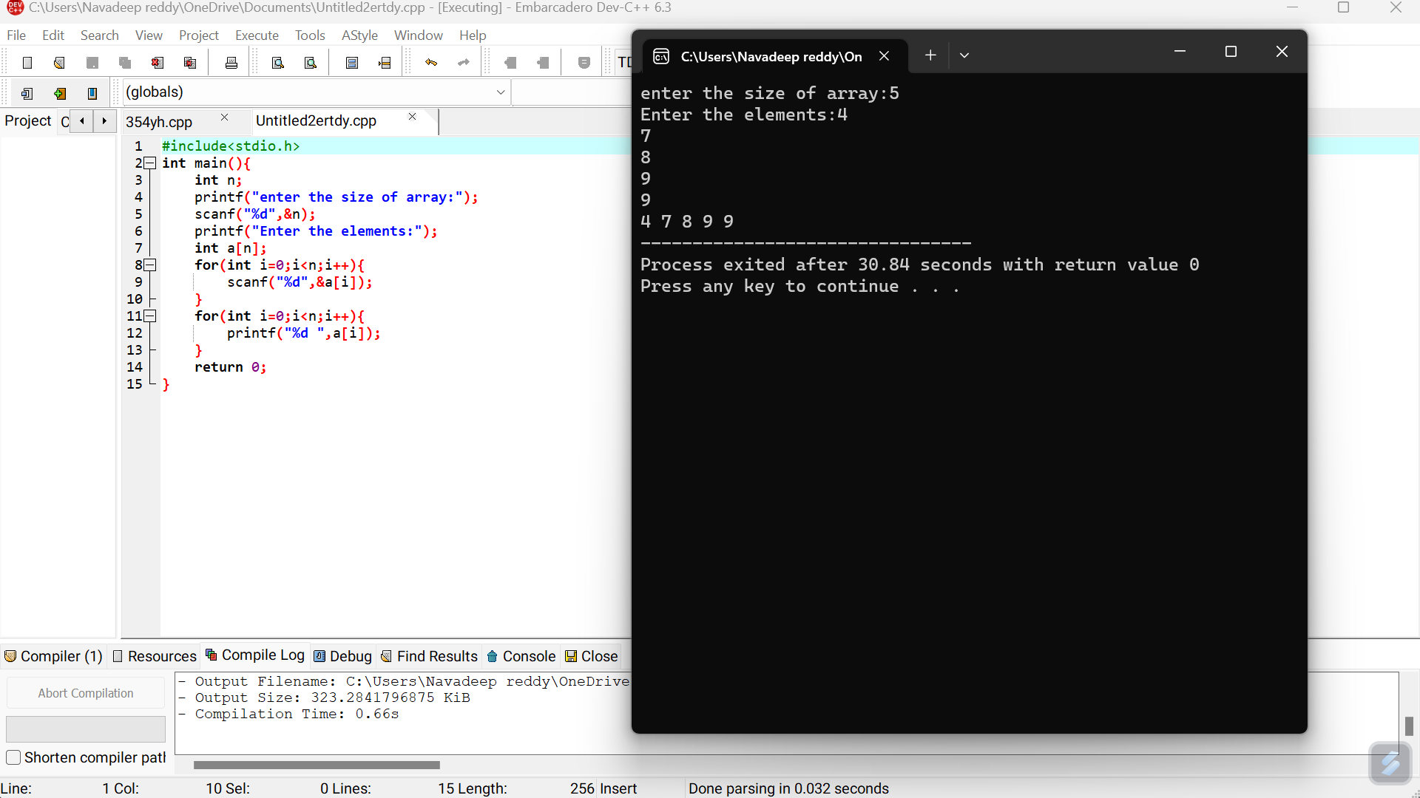

Sample input: 5 and output: 4,7,8,9,9

2)Write a C program to find sum of elements in a given array?

Code:

#include<stdio.h>

int main(){

int size;

printf("Enter the size of the array: ");

scanf("%d", &size);

int arr[size];

printf("Enter the elemnts of gthe array: ");

for(int i = 0; i<size; i++){

scanf("%d", &arr[i]);

}

int sum = 0;

for(int i = 0; i < size; i++){

sum += arr[i];

}

printf("sum of array elemnts : %d\n", sum);

return 0;

}

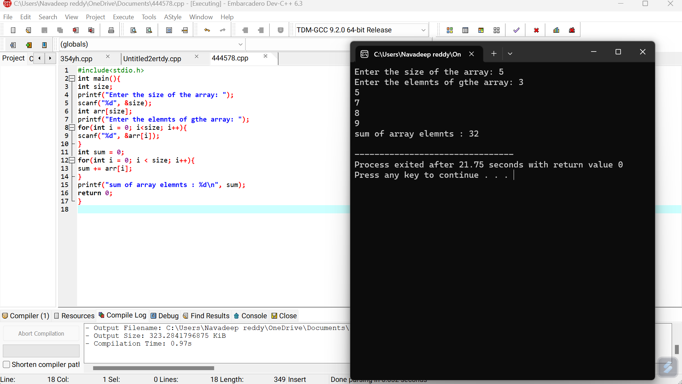

1. Write a c program to find sum of even and sum of odd numbers in the given array?

Code:

#include<stdio.h>

int main(){

int size;

printf("Enter the size of the array: ");

scanf("%d", &size);

int arr[size];

printf("Enter the elements of the array: ");

for(int i = 0; i< size; i++){

scanf("%d", &arr[i]);

}

int sum_even = 0, sum_odd = 0;

for(int i = 0; i< size; i++){

if(arr[i]%2==0){

sum_even += arr[i];

}

else{

sum_odd += arr[i];

}

}

printf("Sum of evevn numbers: %d\n", sum_even);

printf("Sum of odd numbers: %d\n", sum_odd);

return 0;

}

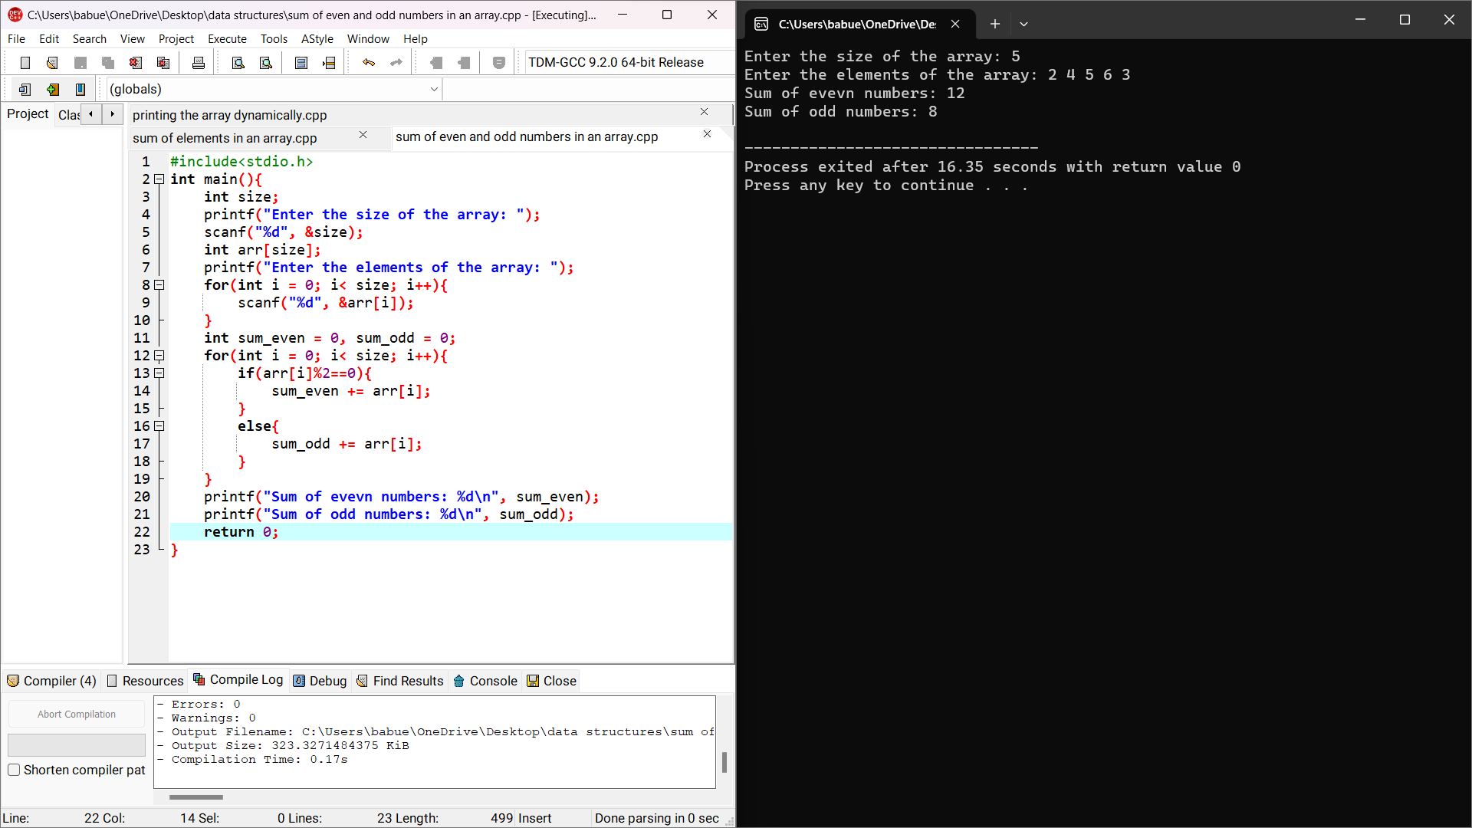

1. Write a c program to perform the following operations
2. Insert an element in an array

Code:

#include<stdio.h>

int main(){

int n,k,p,i;

printf("enter the size of array:");

scanf("%d",&n);

printf("Enter the elements:");

int a[n];

for(int i=0;i<n;i++){

scanf("%d",&a[i]);

}

printf("Enter the element to insert:");

scanf("%d",&k);

printf("Enter the element position to insert:");

scanf("%d",&p);

for(i=n;i>=p;i--){

a[i]=a[i-1];

}

a[p]=k;

n++;

for(int i=0;i<n;i++){

printf("%d ",a[i]);

}

return 0;

}

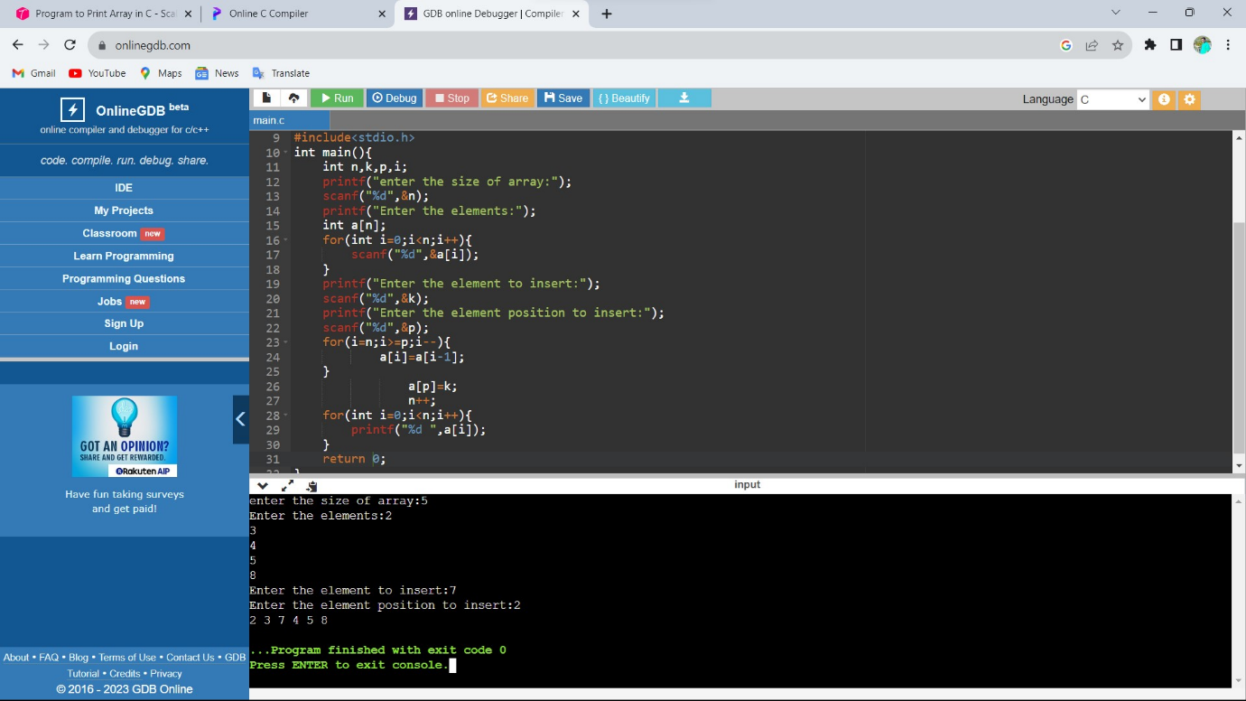

b)Delete an element

Code:

#include<stdio.h>

int main(){

int n,k,p,i;

printf("enter the size of array:");

scanf("%d",&n);

printf("Enter the elements:");

int a[n];

for(int i=0;i<n;i++){

scanf("%d",&a[i]);

}

printf("Enter the element position to delete:");

scanf("%d",&p);

for(i=0;i<n;i++){

if(i==p){

for(int j=i;j<n;j++)

a[j]=a[j+1];

}

}

for(int i=0;i<n-1;i++){

printf("%d ",a[i]);

}

return 0;

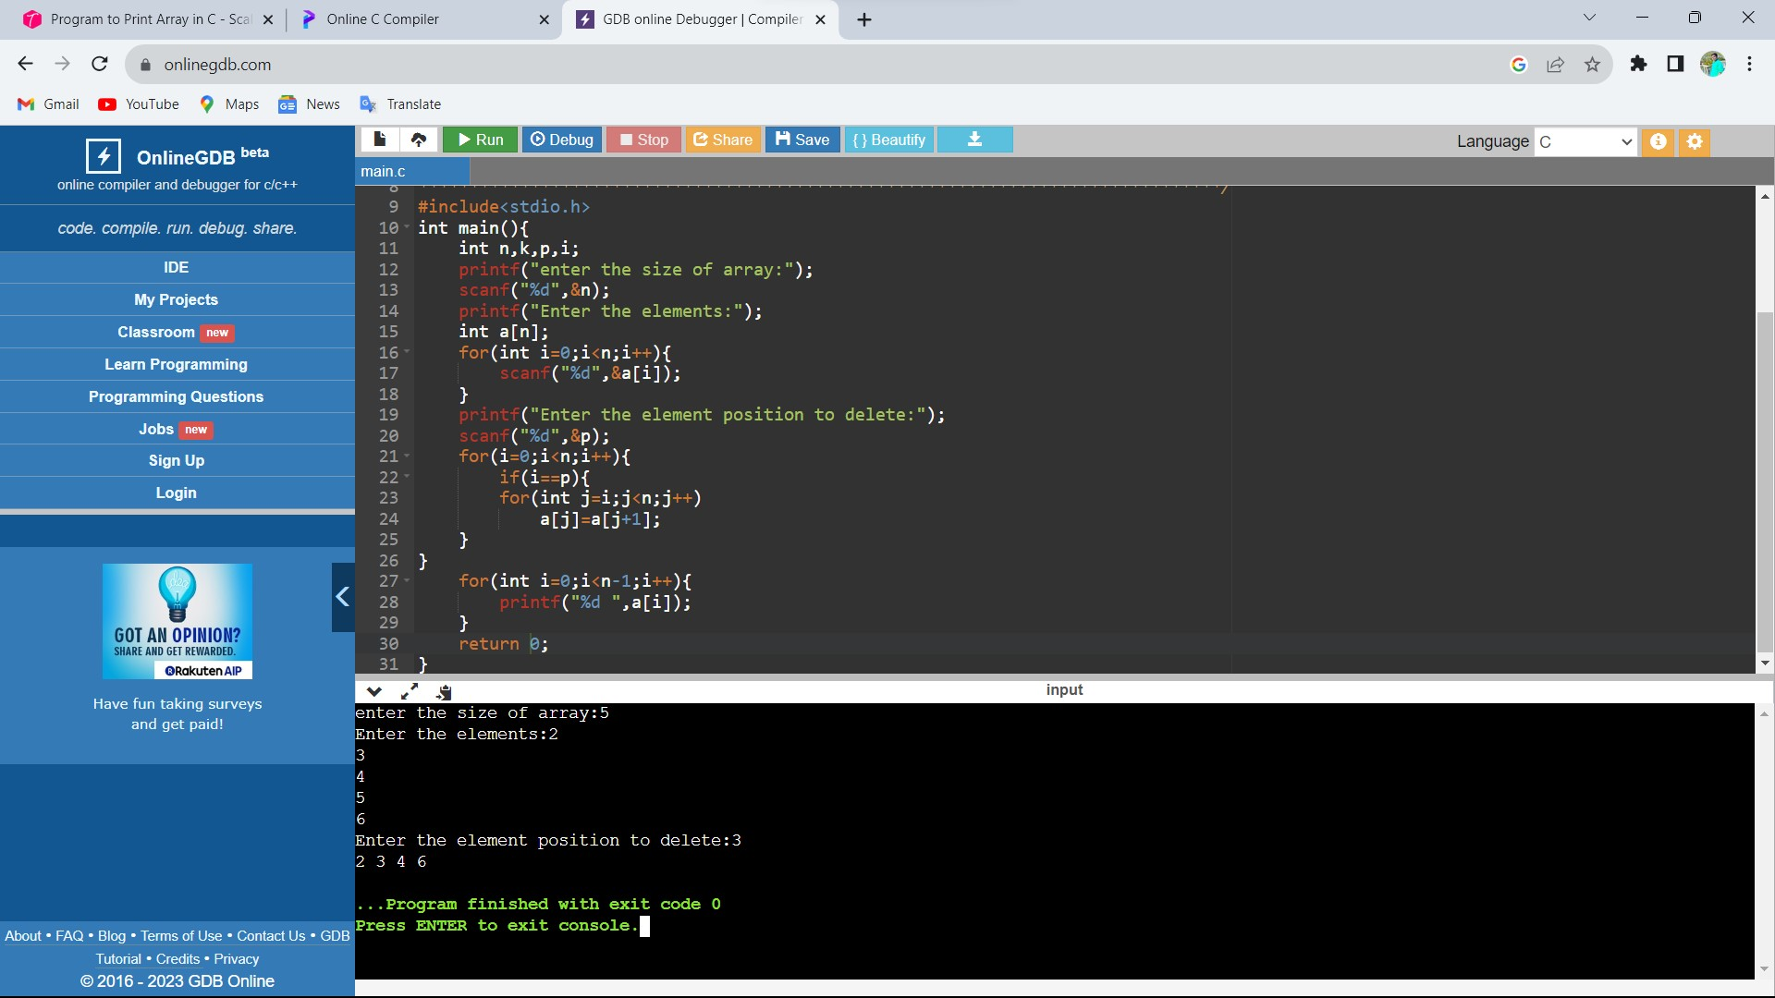

1. Write a c program to merge two arrays?

Code:

#include<stdio.h>

int main(){

int n,m,i,j,o=0;

printf("enter the size of array 1:");

scanf("%d",&n);

printf("Enter the elements:");

int a[n];

for(i=0;i<n;i++){

scanf("%d",&a[i]);

}

printf("enter the size of array 2:");

scanf("%d",&m);

printf("Enter the elements:");

int b[m],k[m+n];

for(j=0;j<m;j++){

scanf("%d",&b[j]);

}

for(i=0;i<n;i++){

k[i]=a[i];

}

j=i;

for(i=0;i<m;i++){

k[j]=b[i];

j++;

}

for(int i=0;i<m+n;i++){

printf("%d ",k[i]);

}

return 0;

}

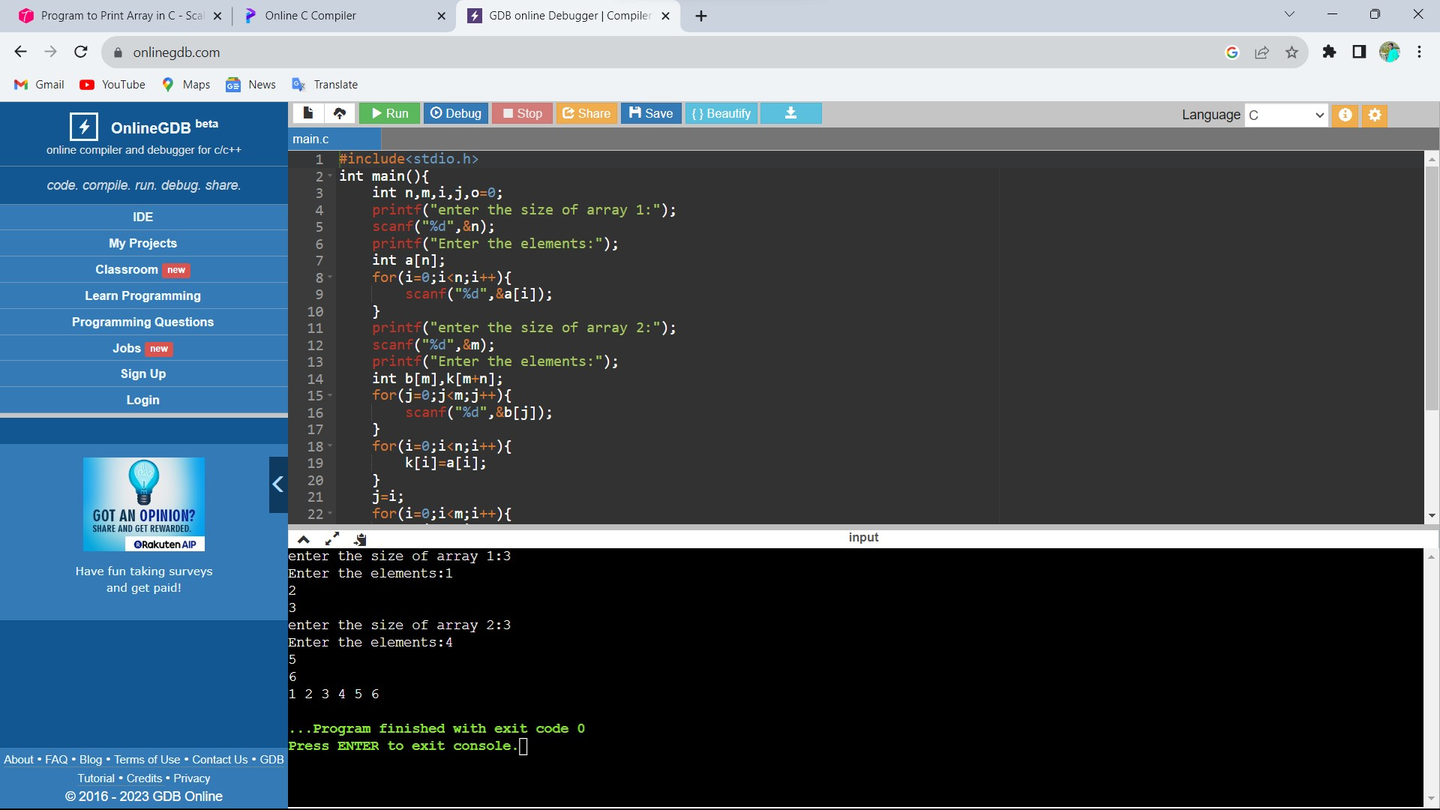

1. Write a c program to find duplicate value in array?

Code:

#include <stdio.h>

#define MAX_SIZE 100

int main()

{

int arr[MAX_SIZE];

int i, j, size, count = 0;

printf("Enter size of the array : ");

scanf("%d", &size);

printf("Enter elements in array : ");

for(i=0; i<size; i++)

{

scanf("%d", &arr[i]);

}

for(i=0; i<size; i++)

{

for(j=i+1; j<size; j++)

{

if(arr[i] == arr[j])

{

count++;

break;

}

}

}

printf("\nTotal number of duplicate elements found in array = %d", count);

return 0;

}

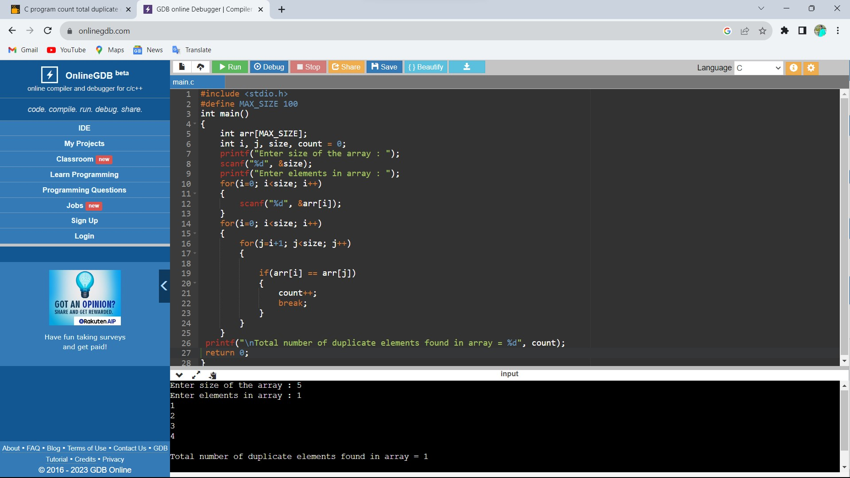

1. Write a C program to find greatest element among array elements?

Code:

#include <stdio.h>

int main() {

int n;

double arr[100];

printf("Enter the number of elements (1 to 100): ");

scanf("%d", &n);

for (int i = 0; i < n; ++i) {

printf("Enter number%d: ", i + 1);

scanf("%lf", &arr[i]);

}

for (int i = 1; i < n; ++i) {

if (arr[0] < arr[i]) {

arr[0] = arr[i];

}

}

printf("Largest element = %.2lf", arr[0]);

return 0;

}

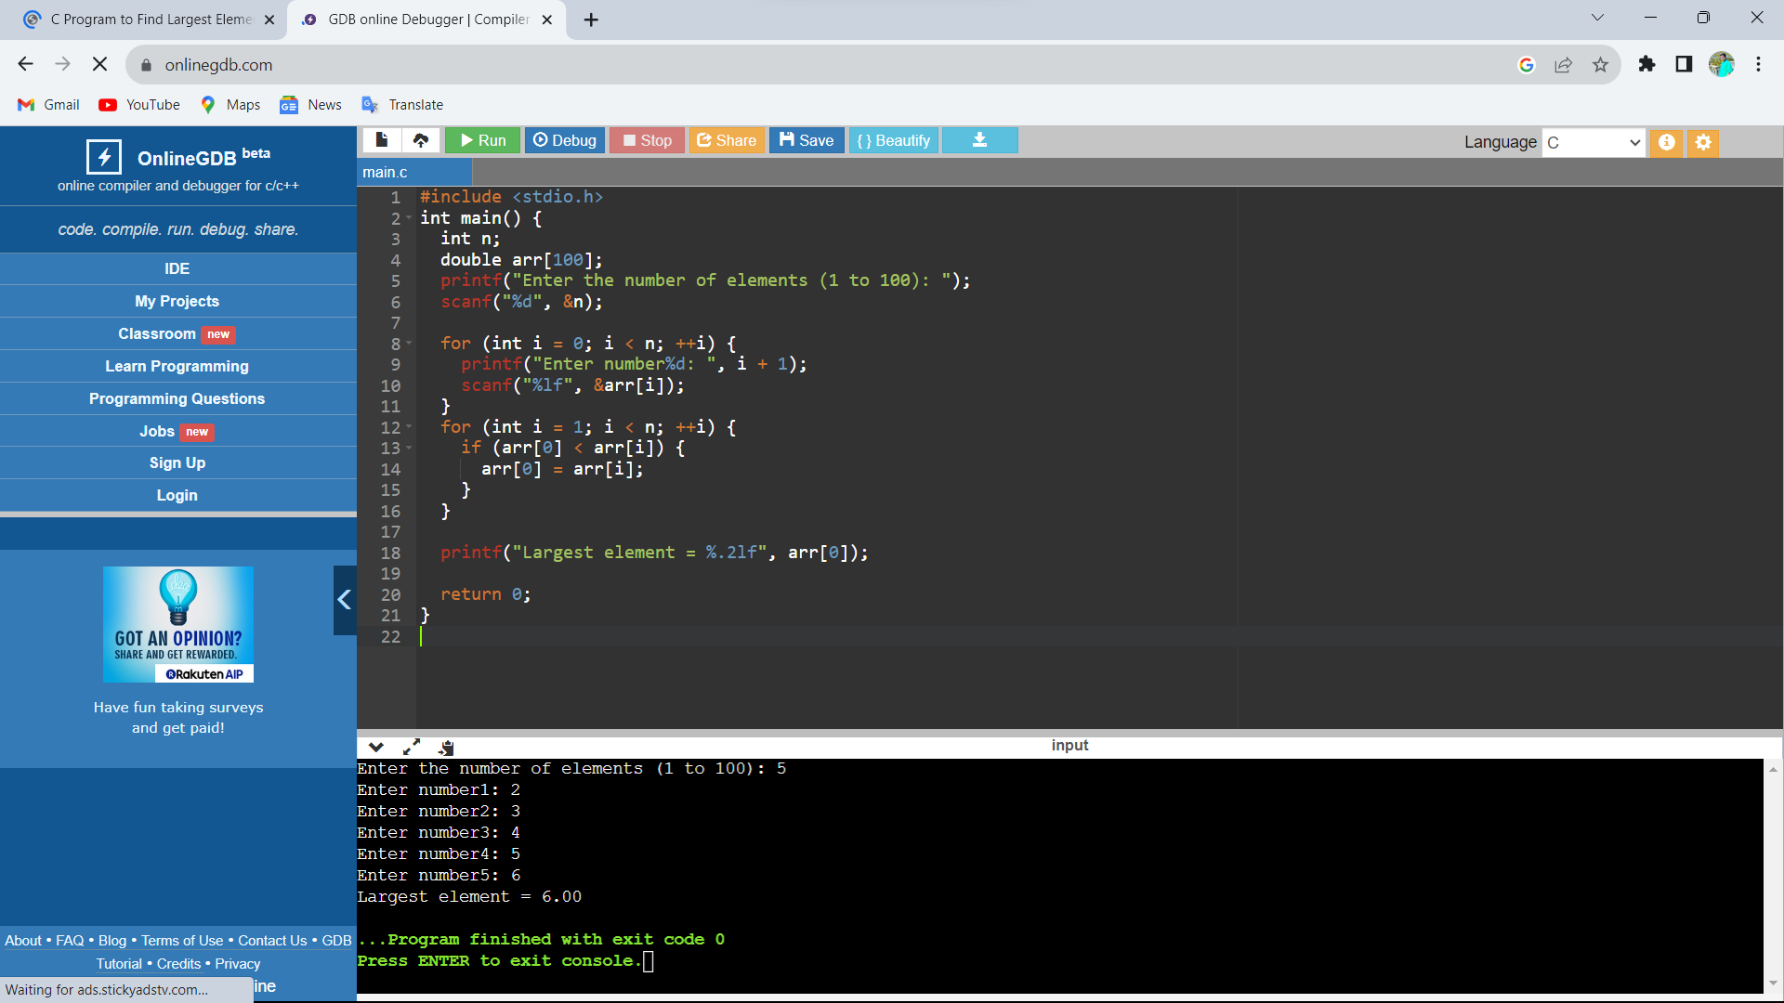

1. Write a C program to search an element in array using linear search?

Code:

#include <stdio.h>

int main()

{

int array[100], search, c, number;

printf("Enter the number of elements in array\n");

scanf("%d",&number);

printf("Enter %d numbers\n", number);

for ( c = 0 ; c < number ; c++ )

scanf("%d",&array[c]);

printf("Enter the number to search\n");

scanf("%d",&search);

for ( c = 0 ; c < number ; c++ )

{

if ( array[c] == search )

{

printf("%d is present at location %d.\n", search, c+1);

break;

}

}

if ( c == number )

printf("%d is not present in array.\n", search);

return 0;

}

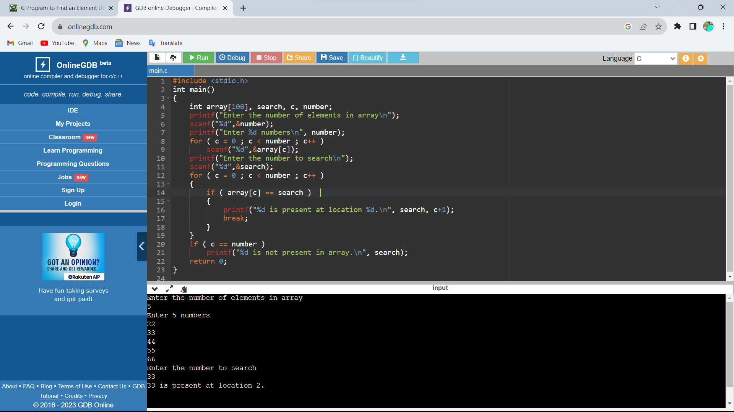

1. Write a c program to search an element in array using binary search?

Code:

//Program Name: BinarySearch.c #include<stdio.h>

int main()

{

int c, first, last, middle, n, search, array[100];

printf("Enter number of elements\n");

scanf("%d",&n);

printf("Enter %d integers\n", n);

for ( c = 0 ; c < n ; c++ )

scanf("%d",&array[c]);

printf("Enter value to find\n");

scanf("%d",&search);

first = 0;

last = n - 1;

middle = (first+last)/2;

while( first <= last )

{

if ( array[middle] < search )

first = middle + 1;

else if ( array[middle] == search )

{

printf("%d found at location %d.\n", search, middle+1);

break;

}

else

last = middle - 1;

middle = (first + last)/2;

}

if ( first > last )

printf("Not found! %d is not present in the list.\n", search);

return 0;

}

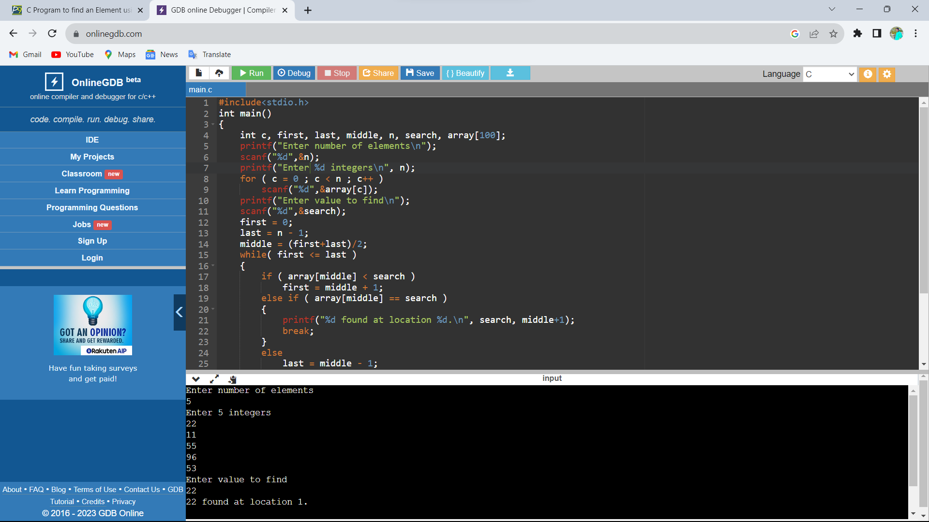

1. Write a C program to reverse a string?

Code:

#include <stdio.h>

#include <string.h>

int main()

{

char s[100];

printf("Enter a string to reverse\n");

gets(s);

strrev(s);

printf("Reverse of the string: %s\n", s);

return 0;

}

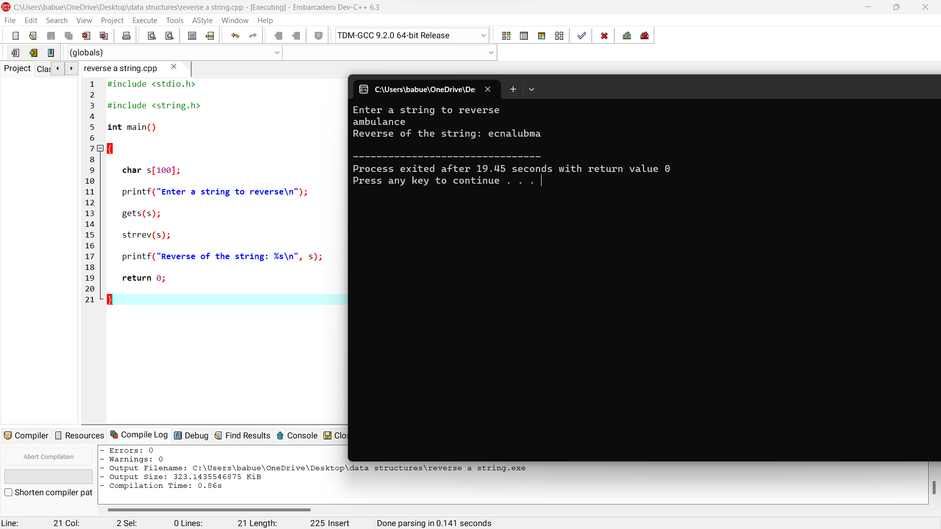

1. Write a C program to check the string palindrome or not?

Code:

#include <stdio.h>

#include <string.h>

int main()

{

char s[1000];

int i,n,c=0;

printf("Enter the string : ");

gets(s);

n=strlen(s);

for(i=0;i<n/2;i++)

{

if(s[i]==s[n-i-1])

c++;

}

if(c==i)

printf("string is palindrome");

else

printf("string is not palindrome");

return 0;

}

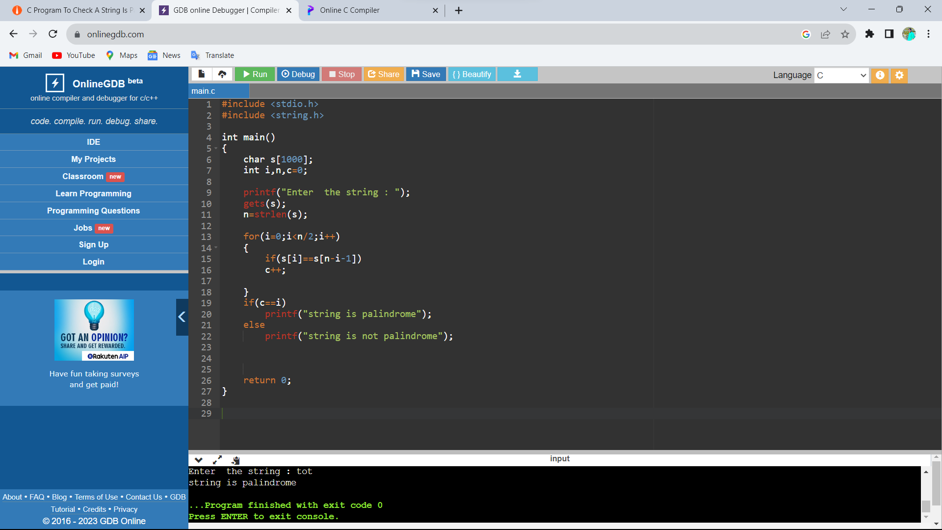

12)Write a C program to count no.of vowels in a string ?

Code:

#include <stdio.h>

#include <ctype.h>

int main()

{

char str[100];

int i, vowels = 0;

printf("Enter the string: ");

scanf("%[^\n]s",&str);

for(i = 0; str[i]; i++)

{

if(str[i]=='a'|| str[i]=='e'||str[i]=='i'||

str[i]=='o'|| str[i]=='u'||str[i]=='A'||

str[i]=='E'||str[i]=='I'||str[i]=='O' ||str[i]=='U')

{

vowels++;

}

}

printf("Total number of vowels: = %d\n",vowels);

return 0;

}

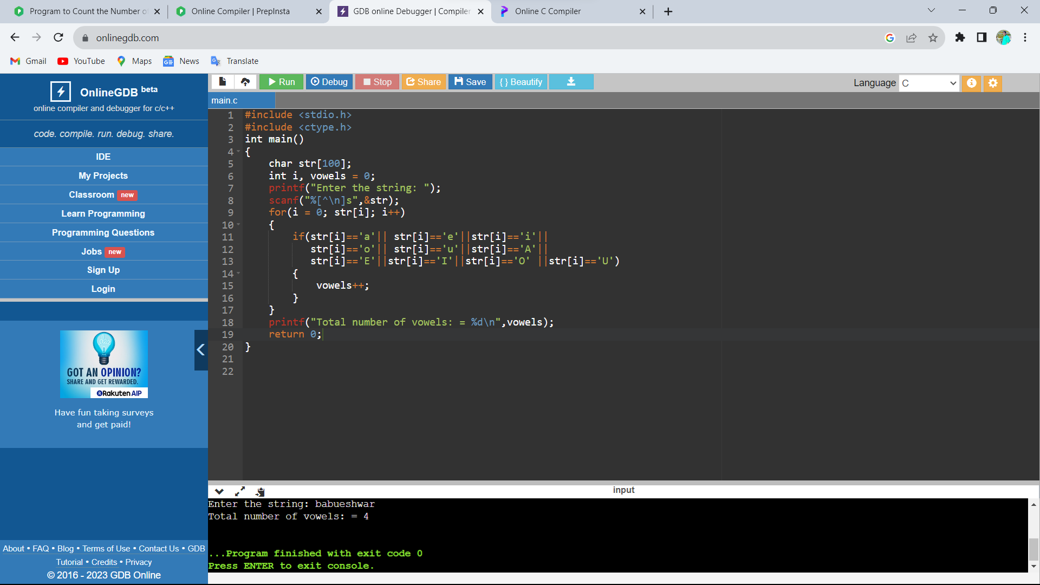

13) Write a C program to find matrix Multiplication?

Code:

#include<stdio.h>

int main() {

int a[10][10], b[10][10], c[10][10], n, i, j, k;

printf("Enter the value of N (N <= 10): ");

scanf("%d", & n);

printf("Enter the elements of Matrix-A: \n");

for (i = 0; i < n; i++) {

for (j = 0; j < n; j++) {

scanf("%d", & a[i][j]);

}

}

printf("Enter the elements of Matrix-B: \n");

for (i = 0; i < n; i++) {

for (j = 0; j < n; j++) {

scanf("%d", & b[i][j]);

}

}

for (i = 0; i < n; i++) {

for (j = 0; j < n; j++) {

c[i][j] = 0;

for (k = 0; k < n; k++) {

c[i][j] += a[i][k] * b[k][j];

}

}

}

printf("The product of the two matrices is: \n");

for (i = 0; i < n; i++) {

for (j = 0; j < n; j++) {

printf("%d\t", c[i][j]);

}

printf("\n");

}

return 0;

}

